SHared automation Operating models for Worldwide adoption
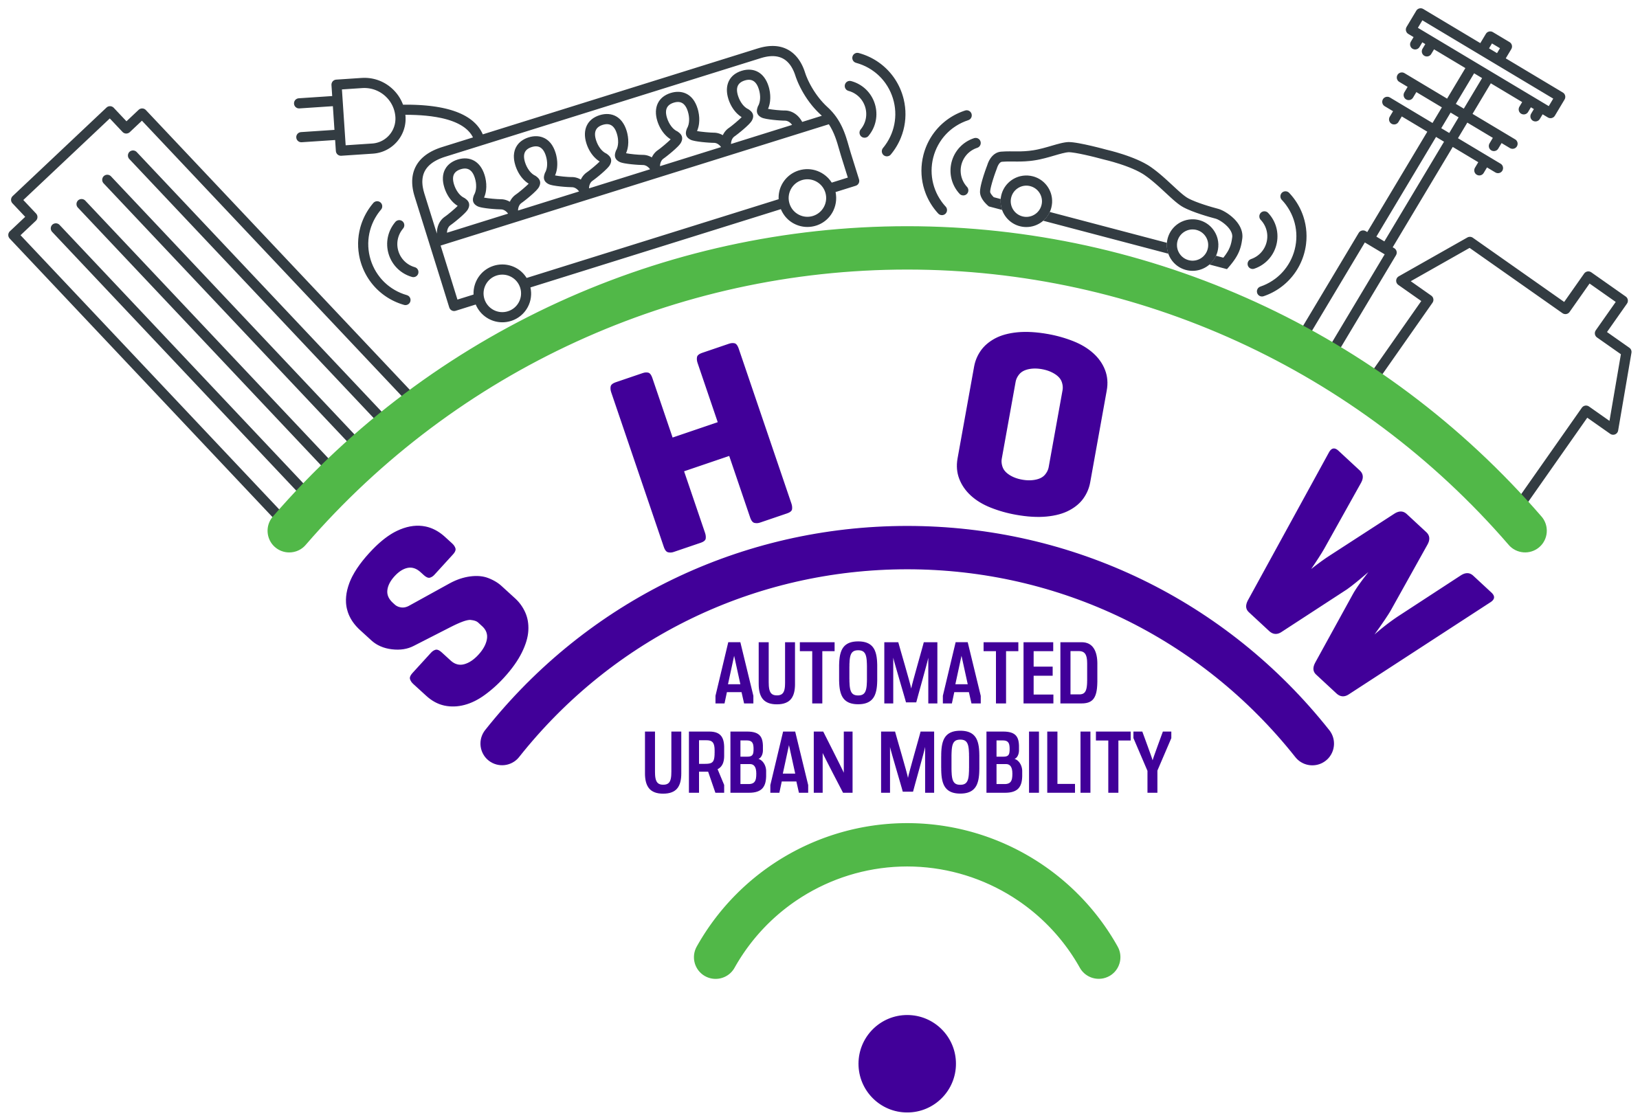

Follower Sites Application Form

  - Introduction
ABOUT SHOW
The SHOW project aims to advance sustainable urban transport through technical solutions, business models and priority scenarios for impact assessment, by deploying shared, connected, electrified fleets of automated vehicles in coordinated Public Transport (PT), Demand Responsive Transport (DRT), Mobility as a Service (MaaS) and Logistics as a Service (LaaS) operational chains in real-life urban demonstrations all across Europe.
SHOW will conduct real-life urban demonstrations taking place in 20 cities in Europe for 24 months, with real service seamless operation in each pilot site lasting at least 12 months. In total, SHOW will deploy a fleet of more than 70 SAE L4/L5 AVs of all types for both passenger and cargo transport in dedicated lanes and mixed traffic, connected to a wide range of supporting infrastructure (5G, G5, IoT) and operating under traffic speeds ranging from 18 to over 50km/h.
For more detailed information on the project, please visit https://show-project.eu/

OUR OFFER TO FOLLOWER SITES
SHOW aims to support the transfer of CCAM (Connected, Cooperative and Automated Mobility) experiences, tools and learnings to at least 10 additional Follower Sites, offering them the opportunity to:

- participate in SHOW on-site demonstrations, workshops, webinars and trainings (workshops, webinars, e-courses) taking into account capacity, resources and areas of interest;
- get acquainted with the SHOW system architecture and dashboard and plug in services and data;
- get their services and solutions hosted and spread through the SHOW marketplace;
- adopt business models, services and technologies derived from the project;
- learn about impact assessment and KPIs for CCAM deployment and apply them in their context;
- develop multiplication plans and actions endorsing SHOW Use Cases aligned with their local roadmaps;
- network with our SHOW community of CCAM experts representing local practitioners, service and technology providers, OEMs, research and academia.
Together with the Follower Sites, we will develop a programme of activities that is adapted to their specific interests, capacities and availability. From May 2022 until December 2023, they will be engaged in SHOW physical and online events on a voluntary and flexible basis, reimbursement of travel costs is foreseen to cover participation in on-site demonstrations. Follower Sites will also have the opportunity to develop multiplication plans and actions with input from SHOW experts, for which a dedicated consultation mechanism will be set up. Multiplication Plans will define local context and partnerships, strategic ambition and objectives, selected use cases and business models for take-up, and include a detailed roadmap towards future deployment; actions refer to the possibility of plugging data from Follower Sites into the SHOW dashboard and/or adopting business models developed by the project.
A Memorandum of Understanding will be signed by the SHOW project leader and the Follower Site representative describing mutual expectations and requirements.
PROCESS AND TIMELINE
The call for SHOW Follower Sites is open until 31St January 2022. Applications will be assessed in February 2022; Follower Sites will be informed about the outcomes of the selection process in March 2022. Selected Sites will be contacted in the course of March 2022 to further define their priorities and interests. On the basis of these discussions a programme of activities will be developed, and a Memorandum of Understanding will be concluded before the end of April 2022.
From May 2022 on, Follower Sites will be invited to join relevant activities, and to connect with the project and the SHOW Demonstration Sites via an online engagement tool, this until the end of the SHOW project in December 2023. For Follower Sites that are committed to developing multiplication plans and actions through a collaborative approach, a separate support scheme will be set up from May 2022 until June 2023. At the end of this process, multiplication plans will be consolidated and bundled by Eurocities and submitted to CINEA in August 2023 as a formal project deliverable.

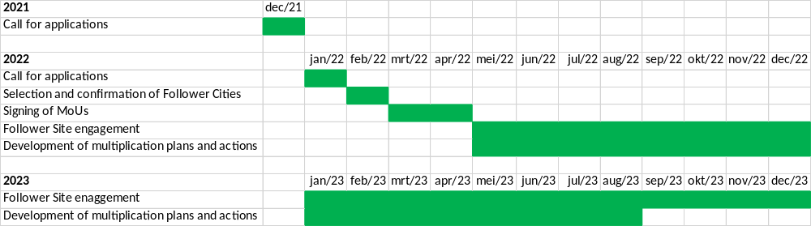

ELIGIBILITY AND SELECTION CRITERIA
The call for applications is open to any public or private entity based in Europe, which has the ambition to either initiate, upgrade or expand shared CCAM services in a designated urban area.
Applications and requests for further information can be sent to peter.staelens@eurocities until 31 January 2022.
Different stages of development and different levels of expertise will be taken into consideration. Follower Site applications will be reviewed by an internal expert panel including Eurocities, UITP, CERTH, Sitowise, VTI and E-Trikala.
Selection criteria that will be applied include:
- Level of ambition towards deployment of shared CCAM services;
- Connection with and complementarity to SHOW use cases;
- Envisaged local integration with local public transport services and the wider multimodal transport system;
- Alignment with sustainable urban mobility planning goals and related objectives in terms of sustainability, safety, accessibility and inclusivity;
- Foreseen cooperation with local administrations and partner organisations.
  - Applicant information

Organisation
Name of the Organisation
Type of Organisation (e.g. local administration, transport authority, transport operator, research institute etc.)
Address
Street & Nr
Postal code
City
Country
Contact information
Title (Mr/Ms/Mx)
First Name
Last Name
Tel.
Email Address
Follower Site characteristics
Please describe your ambitions regarding CCAM deployment, which shared CCAM services you plan to initiate, upgrade or expand and how these are expected to complement the existing public transport services and wider multimodal transport systems – 500 words max

Please describe the city, district or urban area where you consider initiating, upgrading or expanding shared CCAM services (e.g. geography, population, functionality etc.) - 250 words max
If already at a more advanced stage of planning and deployment, please provide information on the specific CCAM services, type and number of CAVs, SAE level of automation and maximum traffic speeds, also briefly describe to what extent these CAVs will interact with local traffic management, communication and road infrastructure - 500 words max
Please describe to what extent your CCAM ambitions will contribute to sustainable urban mobility planning goals and related objectives in terms of sustainability, safety, accessibility and inclusivity, and – in case you apply as private entity - to what extent you plan to cooperate with local administrations and partner organisations – 250 words maximum
Areas of interest
Please indicate (X) which SHOW use cases are of specific interest (you can click on the link for more details)
UC1 Family: Automated mobility in cities
UC1.1: Automated passengers/cargo mobility in Cities under normal traffic & environmental conditions
UC1.2: Automated passengers/cargo mobility in Cities under complex traffic & environmental conditions
UC1.3: Interfacing non automated vehicles and travellers (including VRUs)
UC1.4: Energy sustainable automated passengers/cargo mobility in Cities
UC1.5: Actual integration to city TMC
UC1.6: Mixed traffic flows; AVs and non AVs mixed in the same traffic flows
UC1.7: Connection to Operation Centre for tele-operation and remote supervision
UC1.8: Platooning for higher speed connectors in people transport
UC1.9: Cargo platooning for efficiency
UC1.10: Seamless autonomous transport chains of Automated PT, DRT, MaaS, LaaS
UC2 Family: Automated mixed mobility in cities
UC2.1: Automated mixed spatial mobility
UC2.2: Automated mixed temporal mobility
UC3 Family: Added Value services for Cooperative and Connected Automated mobility in cities
UC3.1: Self-learning Demand Response Passengers/Cargo mobility
UC3.2: Big data/AI based added value services for Passengers/ Cargo mobility
UC3.3: Automated parking applications; namely AVs self-parking functions
UC3.4: Automated services at bus stops
UC3.5: Depot management of automated buses
UC3.6: COVID-SAFE Transport
Please indicate (X) which cross-cutting topics, activities and services are of interest
User engagement / user opinion
Business and operating models
Ethical and privacy issues
Legal and regulatory aspects
Technical verification & commissioning
Simulation models and tools
System architecture
Data collection and management
CCAM services marketplace
Automated vehicles function
Infrastructure functions and systems
Integration of CCAM in Sustainable Mobility Planning processes
Impact assessment
Please indicate (X) whether you are interested in developing a multiplication plan and activities; if yes, please briefly explain what you would like to focus on – 250 words max
Our organisation is interested in developing a multiplication plan and activities

  - More information
For more information, support and advice, please contact:

 |  | Peter Staelens | Senior Project Coordinator  email: peter.staelens@eurocities.eu  t: +32 2 552 08 66 |  eurocities.eu | @EUROCITIES

CAVs: Connected and Automated Vehicles

